**DOCKER STATS**

STEP-1:SINGLE CONTAINERS

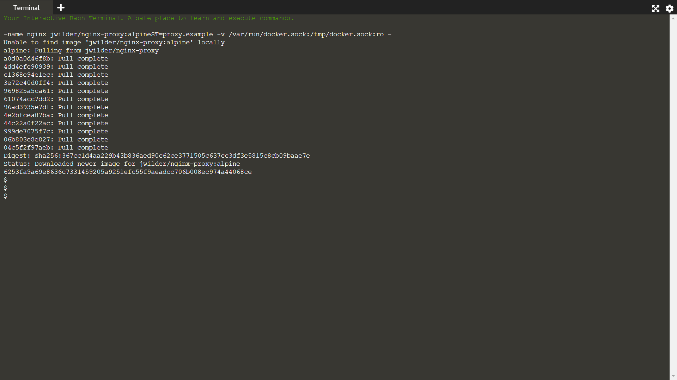

The environment has a container running with the name nginx. You can find the stats for the container by using:

docker stats nginx

This launches a terminal window which refreshes itself with live data from the container.

To quit, use CTRL+C to stop the running progress.

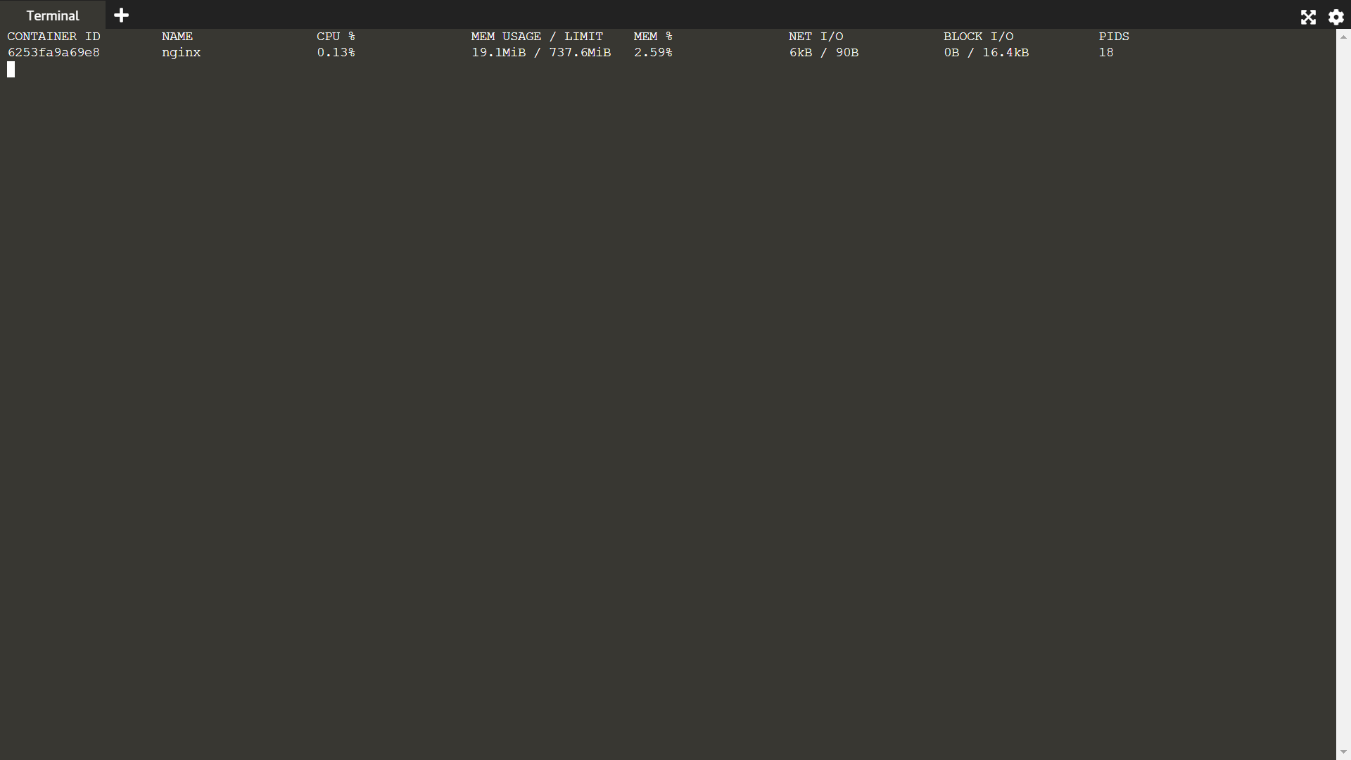

STEP-2: MULTIPLE CONTAINERS

By combining the two we can take the list of all our running containers provided by docker ps and use them as the argument for docker stats. This gives us an overview of the entire machine's containers.

docker ps -q | xargs docker stats

